**KubixSquare July Internship**

**Front-End Team 6**

**Final Report**

**P.S.:**Create a fully functional website (ex Merklebits) using react technology. Merklebits is a parent company which has many ventures in different domains. Website should look professional, user friendly UI and shouldn’t take much loading time. Ventures can be assumed in e-commerce, education, digital marketing and finances. The Website should use three.js library to make it more interactive and give a unique look

**Members:**

Akshay Giridharan

Anushka Patil

Yashodeep Pawar

Alaster Cheeramkuzhyil

Avnish Raut

**Final Report :**

**1)First we did research on the topic**

**2)we divided the parts among us**

**3) The main page is build using React and the other pages are basic**

**We have also added animations in the main page**

**4) We tried to implement others in React as well but it had some issues**

**5) We were not able to implement three js as it would take a long time to learn and implement**

**6)We had a great experience working as a team and would like to thank KubixSquare for giving us the opportunity**

**7)Everything has been updated on trello and github**

**Trello Board:**

<https://trello.com/b/H09RLaUF/frontend-team-6>

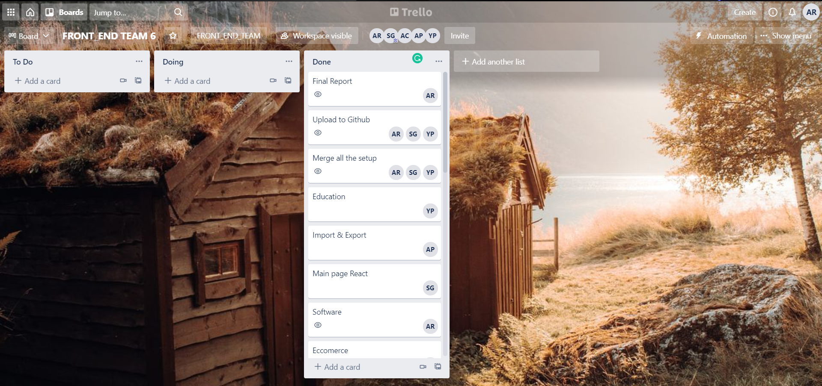

**Output for Main page which is in React**

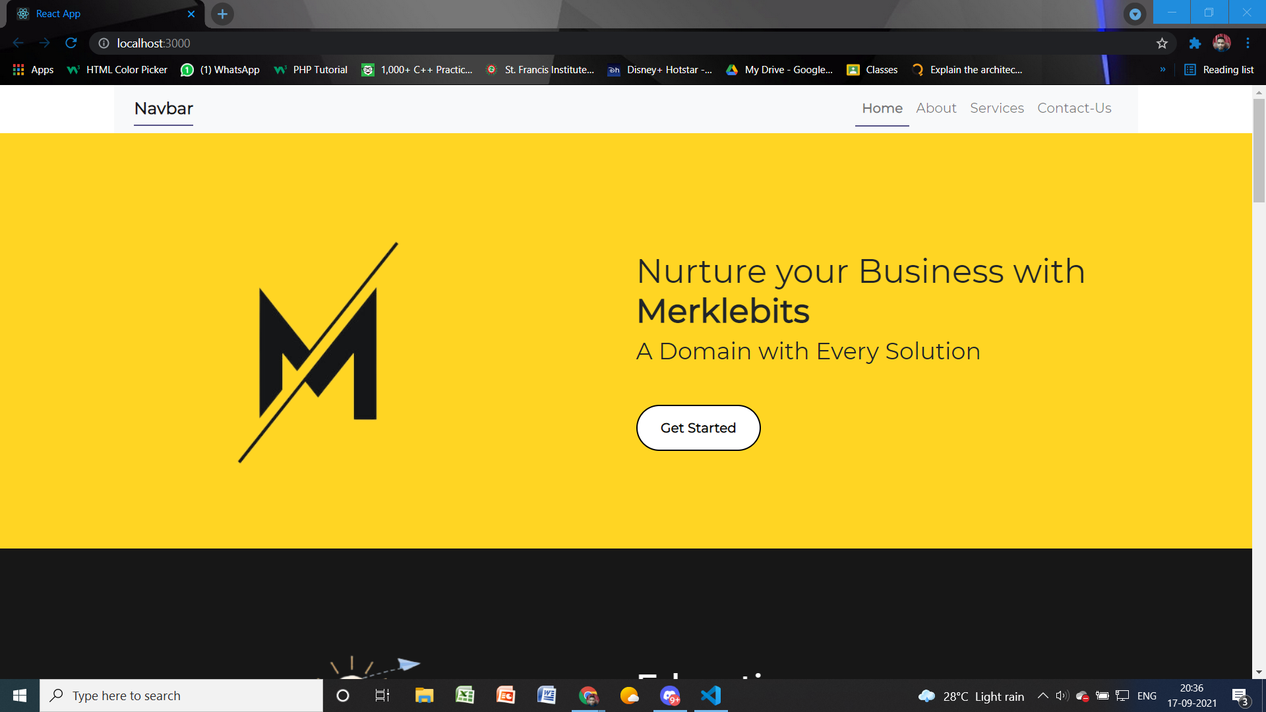

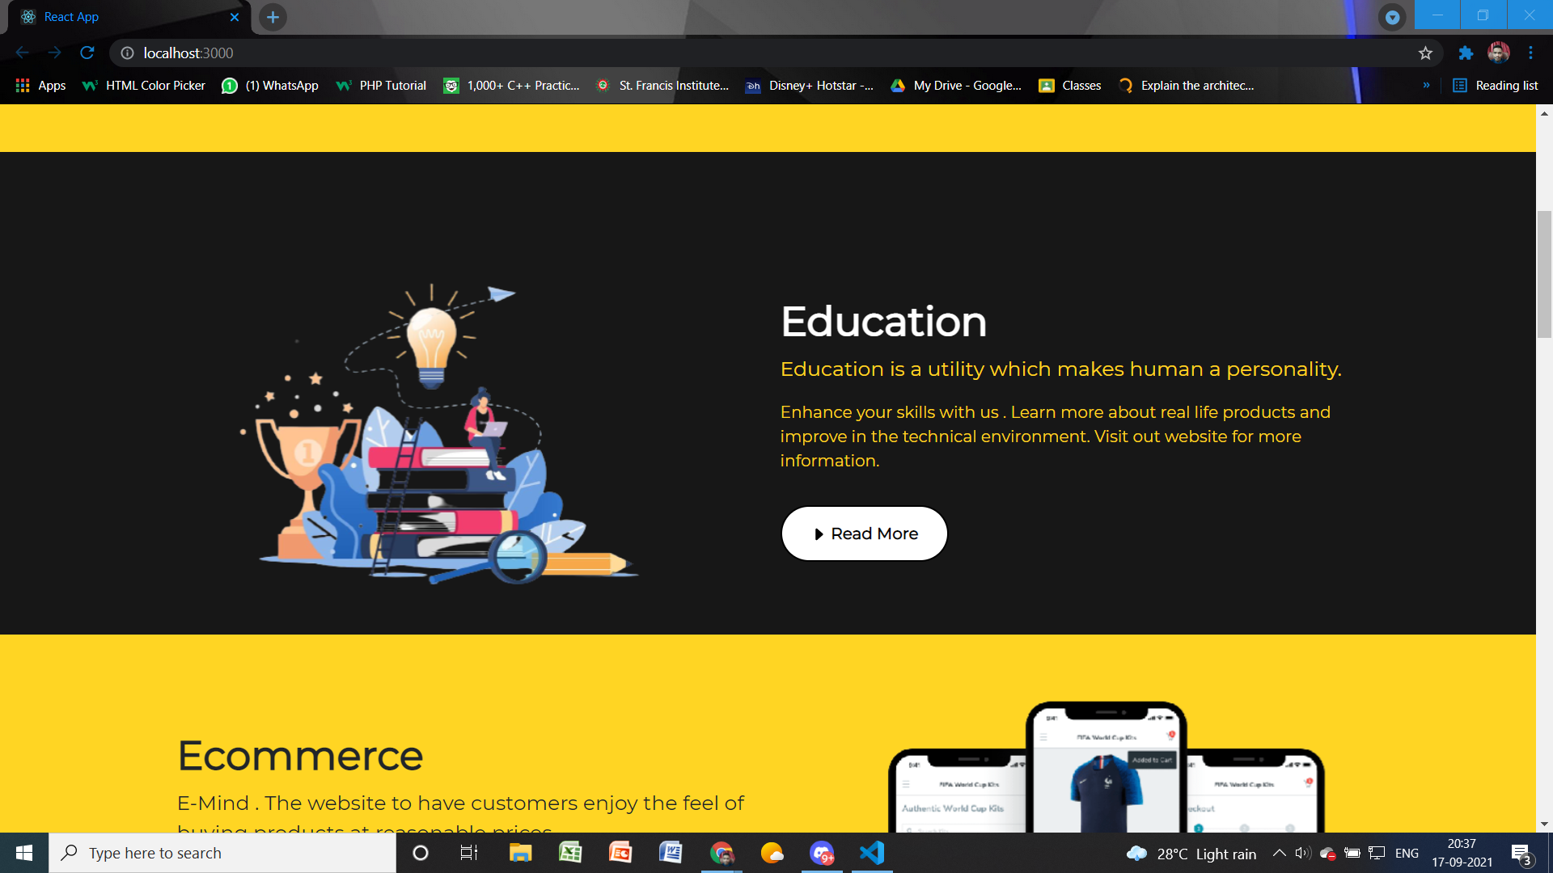

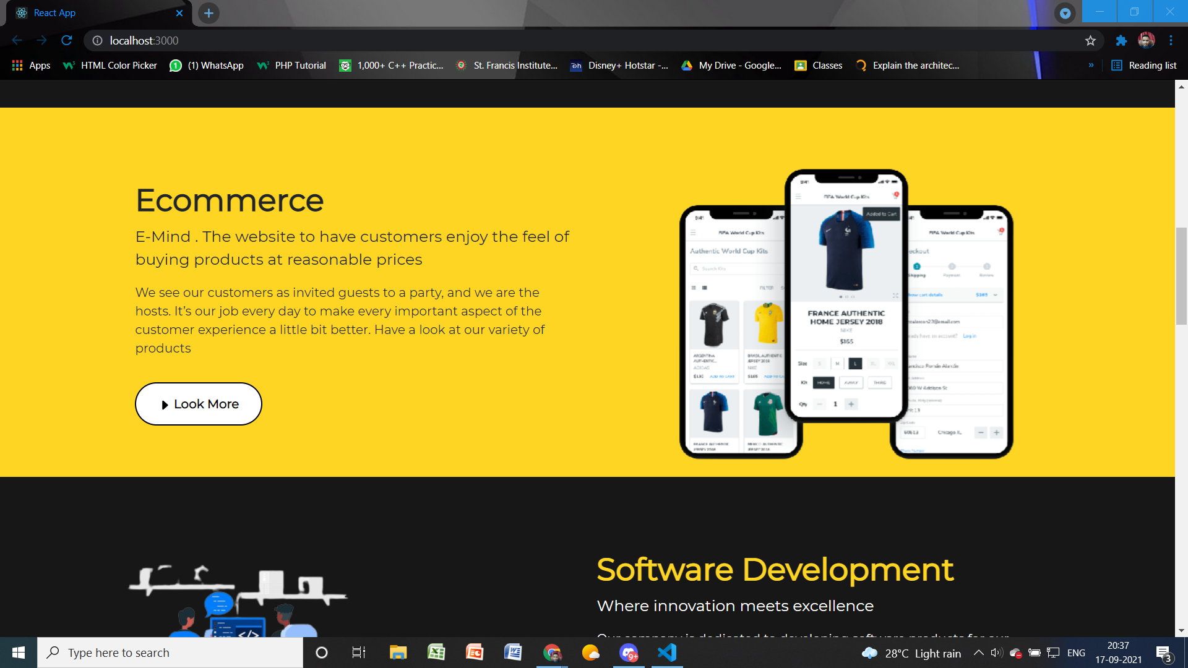

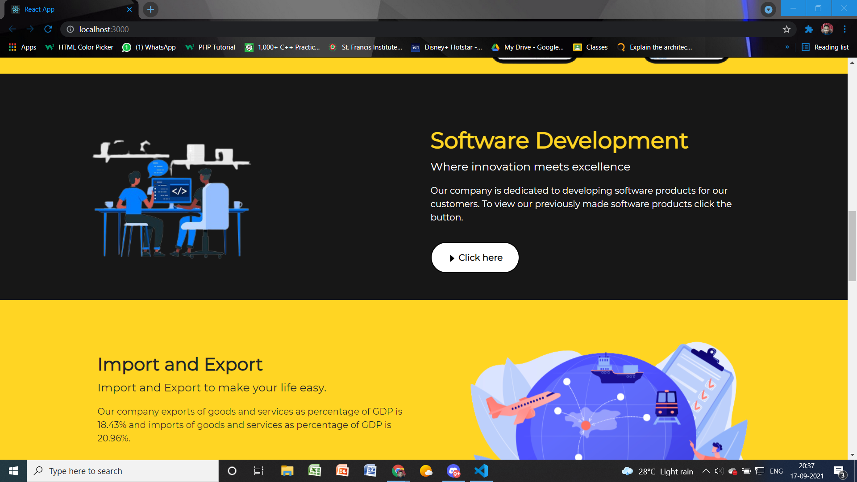

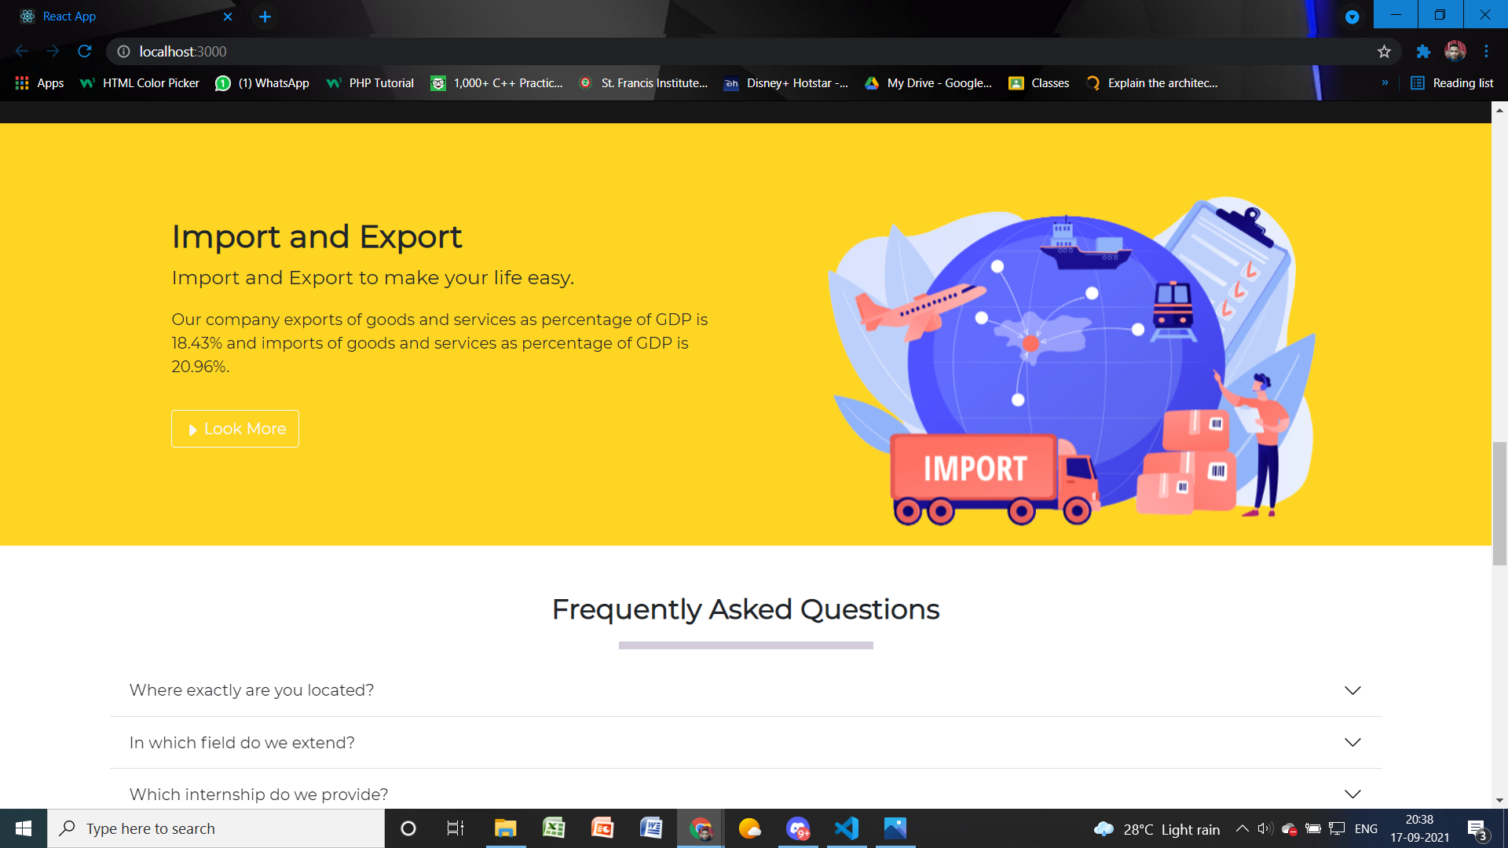

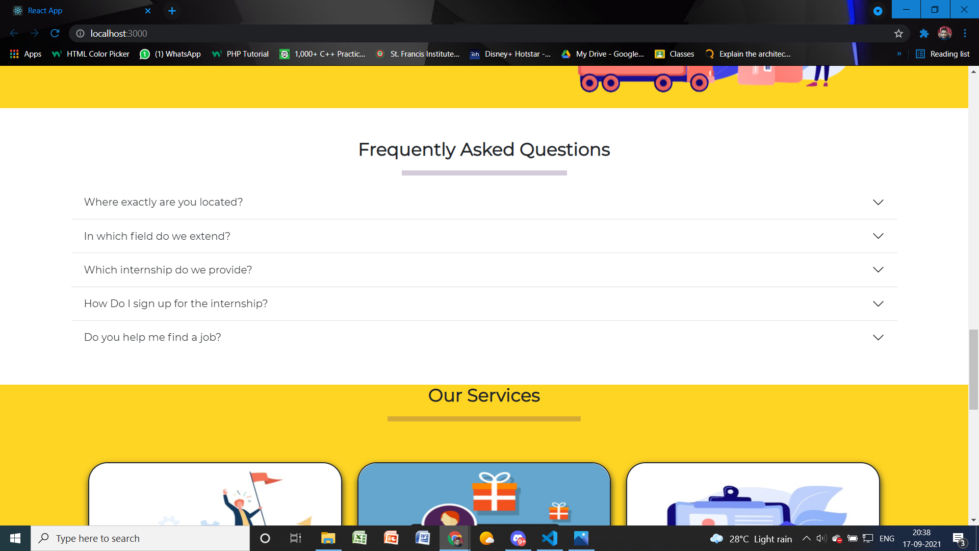

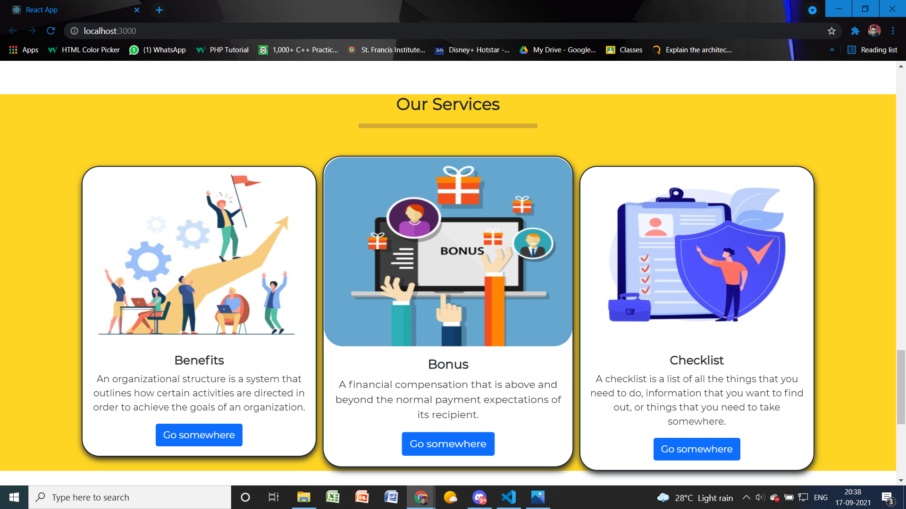

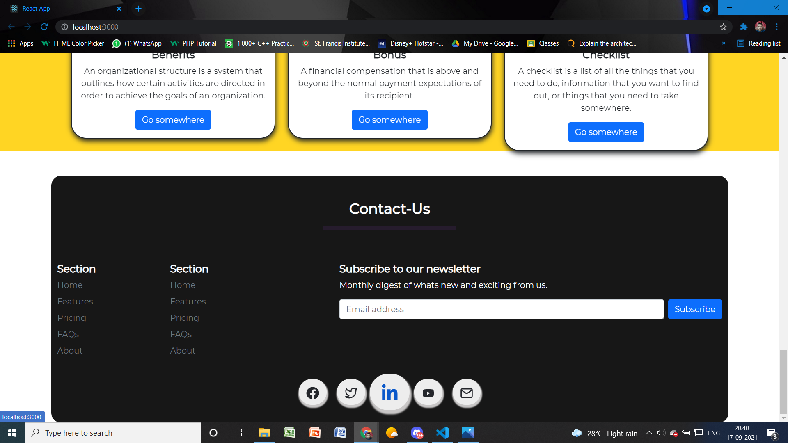

**Output for Software**

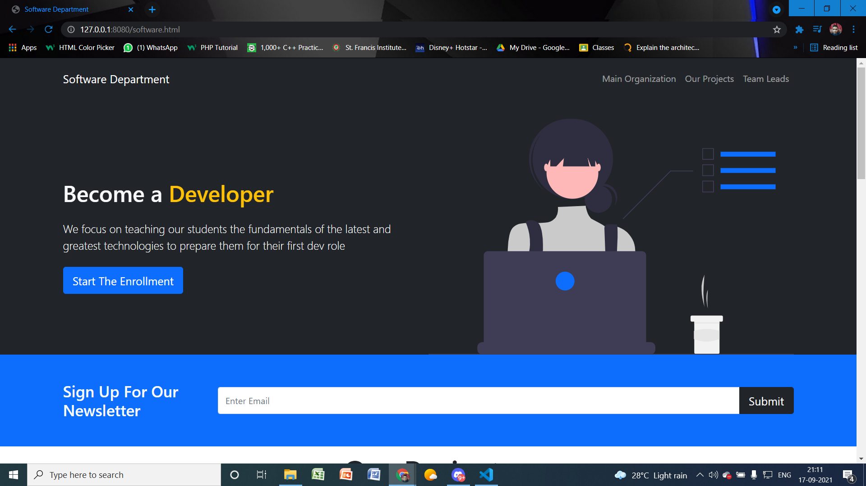

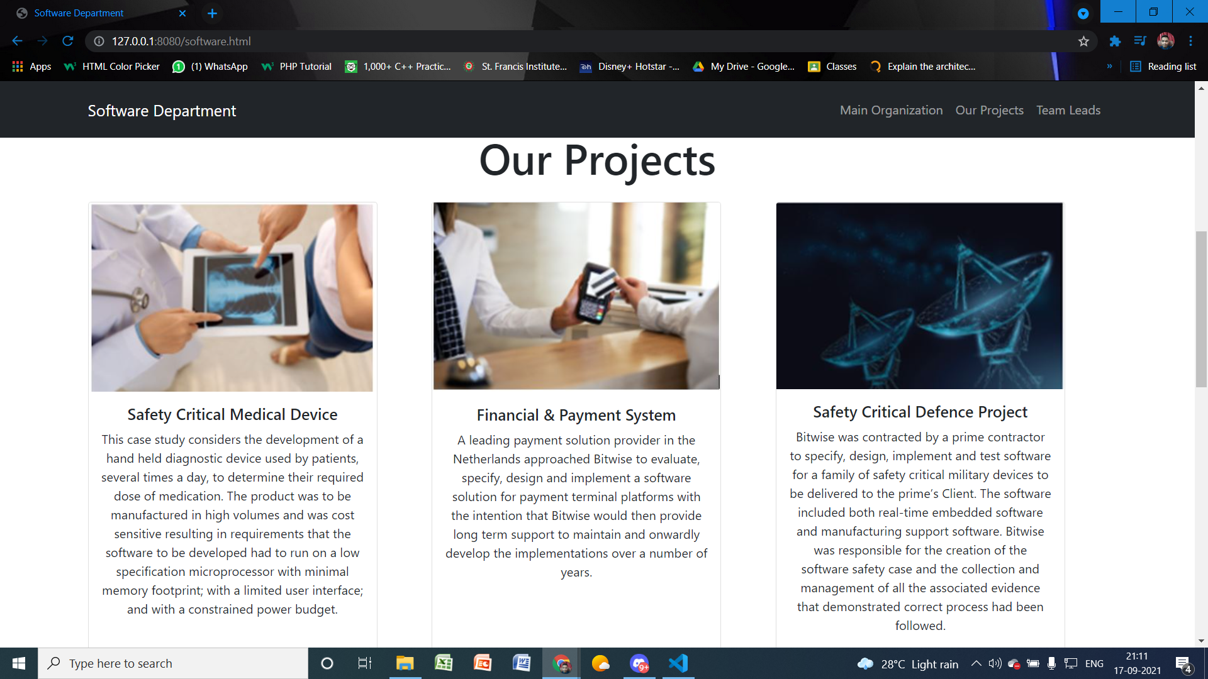

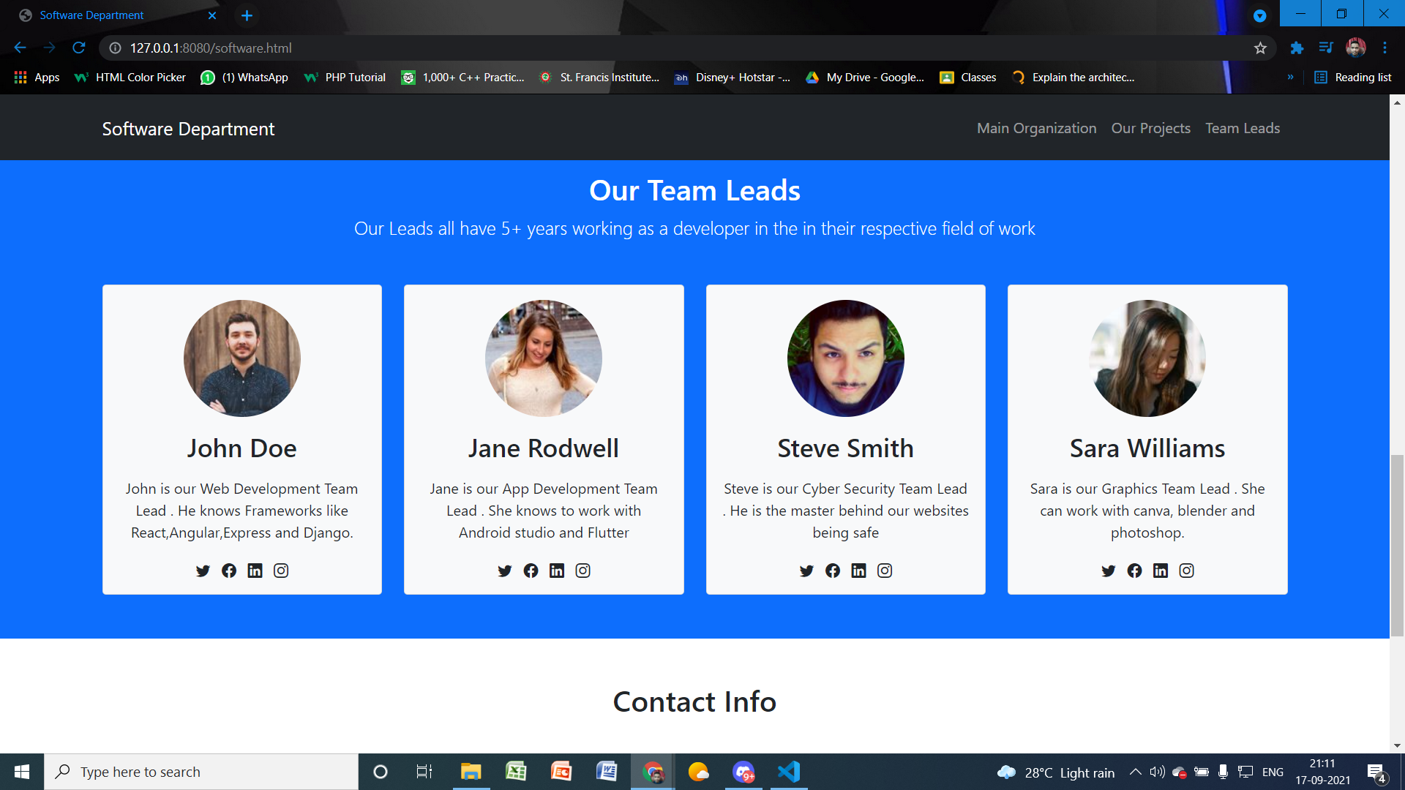

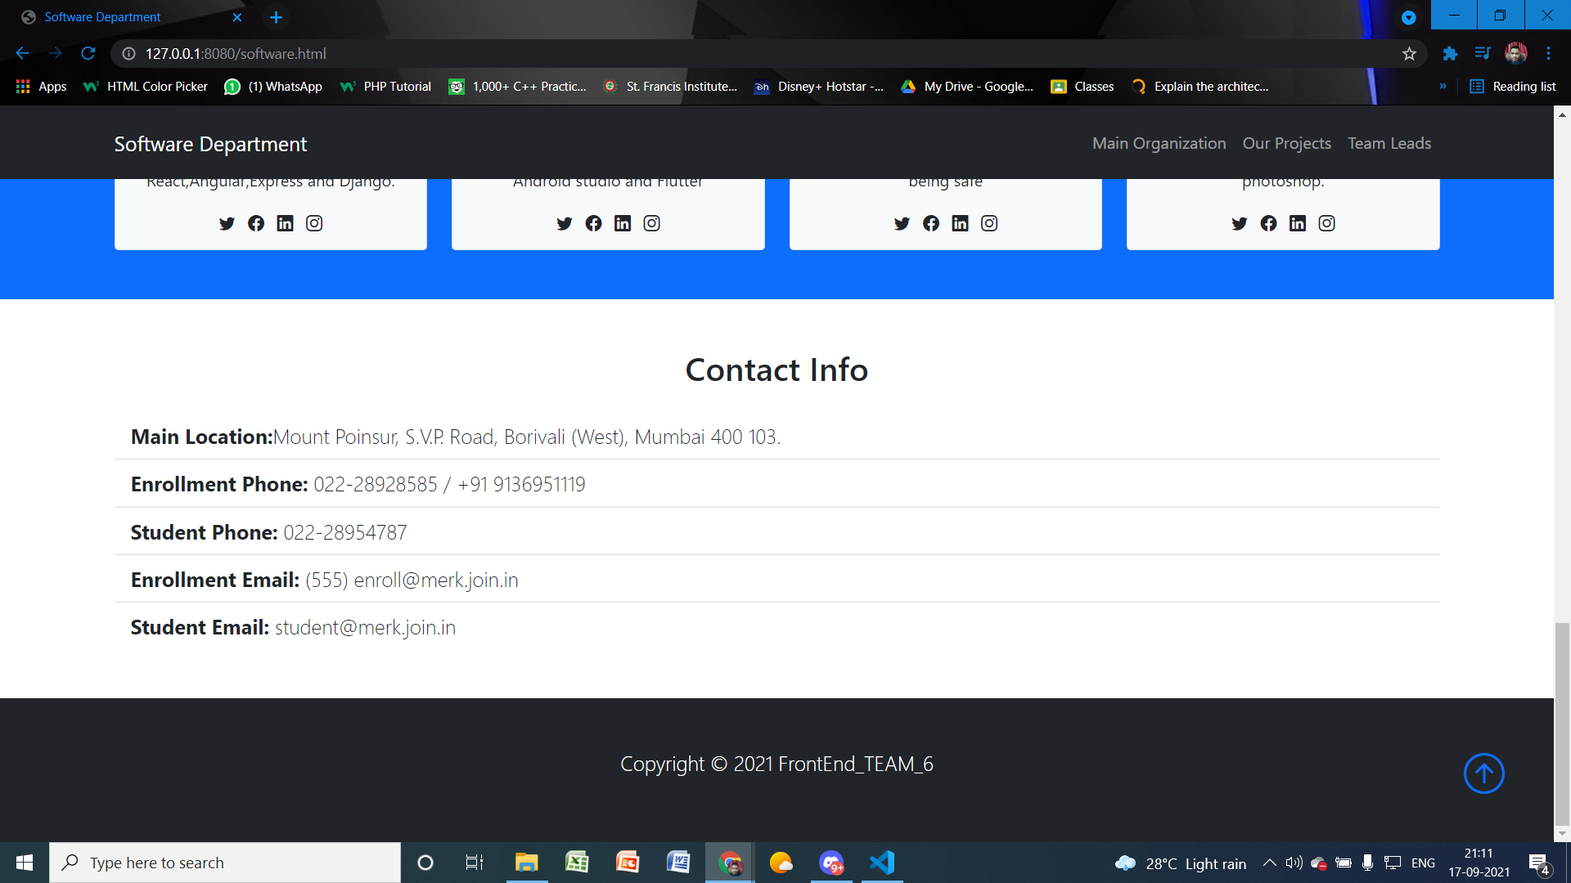

**Ecommerce**

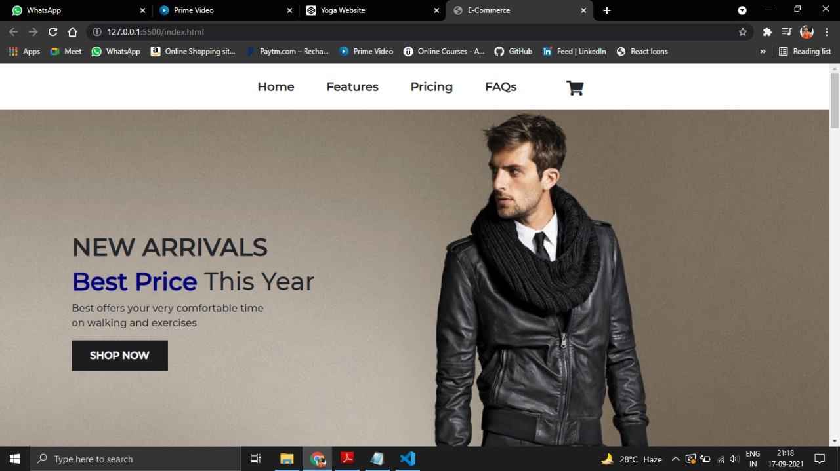

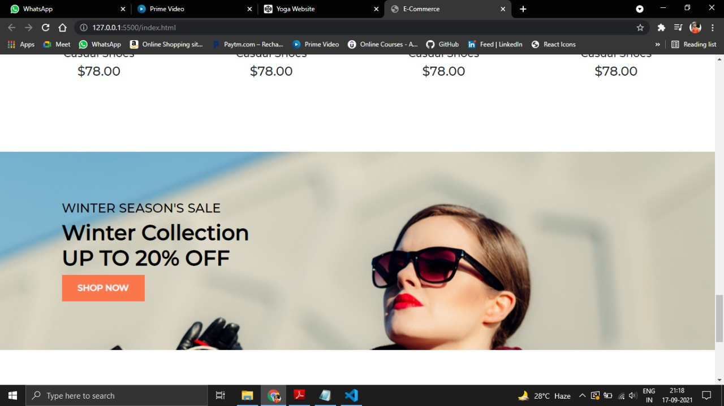

**Import And Export**

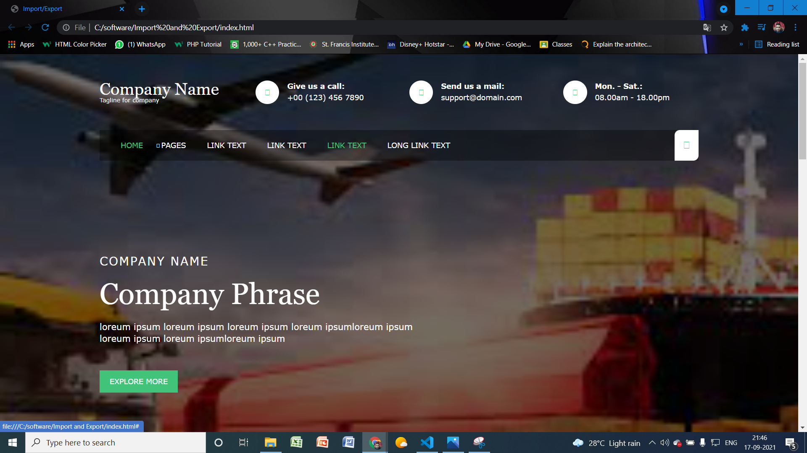

**Education**

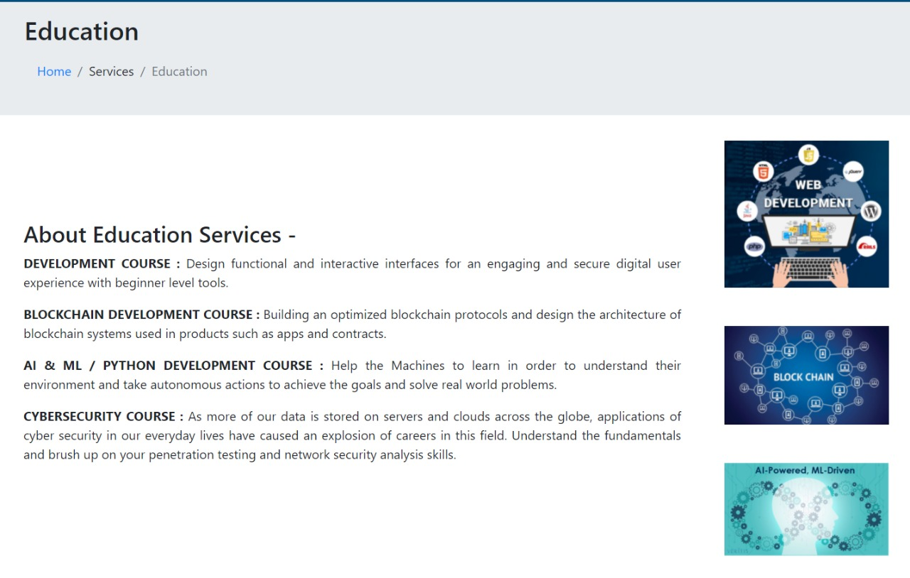

**Aboutus**

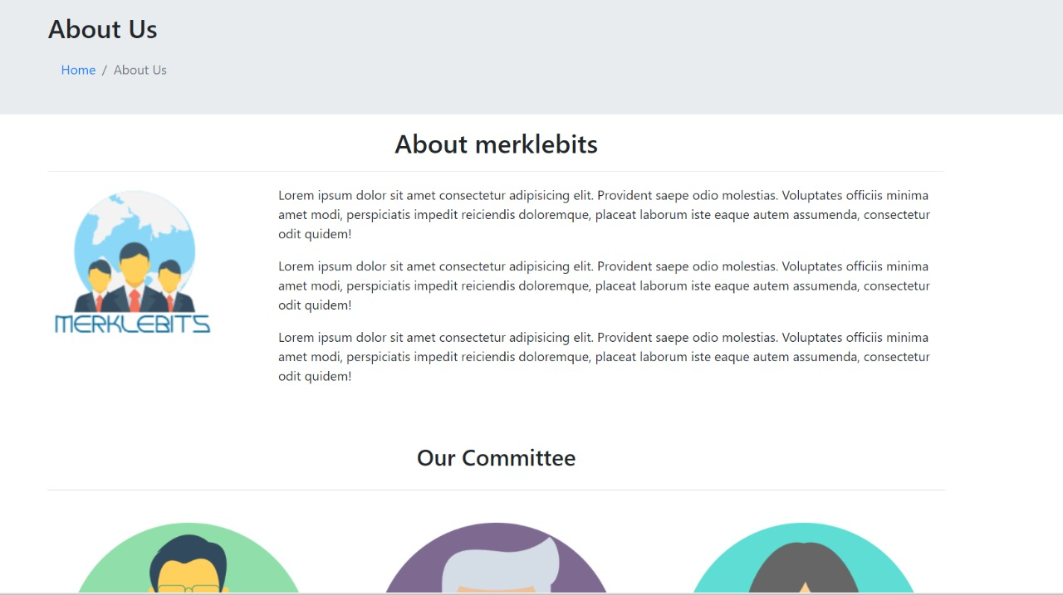

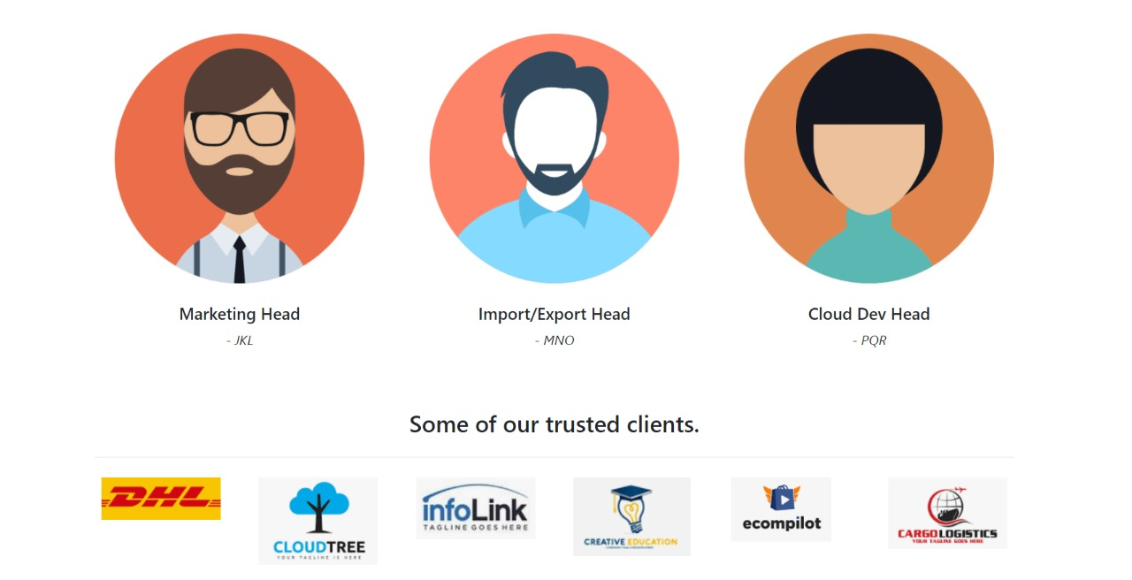

**Contactus**



**Github Link:**

<https://github.com/Avnish-Raut/FRONTEND_TEAM_6>